MongoDB

* It is a NoSQL database
* It stores records as document which is a Javascript Object which will have key and value
* It is built for modern applications, because the data structure would not be always same
* It doesn’t follow any rules of SQL, like table must have only related data and relationship of the tables is created in another table foreign key constraint and so on
* Performance wise it is better and it gives lot of inbuilt functions to perform operations on the database
* It can handle the data in any structure and also data structure can be dynamic
* MongoDB stores the related data in as an embedded document, it means it doesn’t keep the related data in a separate place, so that the read operations would be faster

Advantages of using documents;

1. Documents are like objects, they are easily compatible with many programming languages like Javascript, Java, C#, because it stores in a Javascript format or JSON format
2. Embedded documents and arrays can reduce expensive read and join operations
3. Dynamic Schema support

MongoDB Terminologies

1. Collections: It is going to store documents, it will have a name using which you can store the documents, it is like a table in RDBMS
2. Document: It is a record that will have data with properties & values, it can be a simple document or arrays of document or lot of embedded documents, it is like a row in a table
3. Database: It is an instance that will have multiple collections.

Note: MongoDB is case sensitive, if you create a collection with emp and another collection with EMP then both are different they are not one and the same.

How to install MongoDB

You can install Mongodb in 2 ways.

1. Installer file
2. Zip file having the installation folder (easier)

2nd way you can prefer as you will get the installation directory once you unzip the zip file

You can download the installation zip file from the below website

<https://www.mongodb.com/try/download/community>

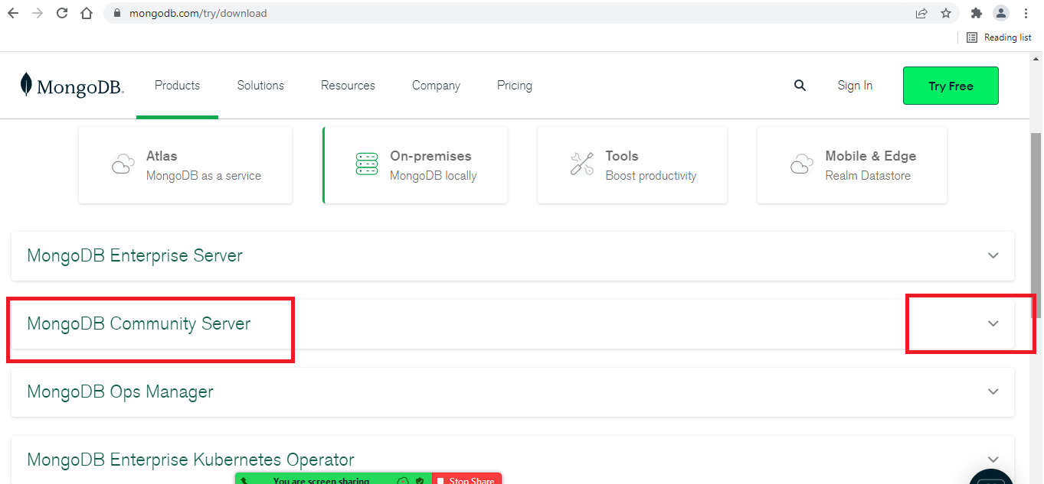

You have to select MongoDB Community Server from where you can select the mongodb zip file that will have the installation folder zipped.

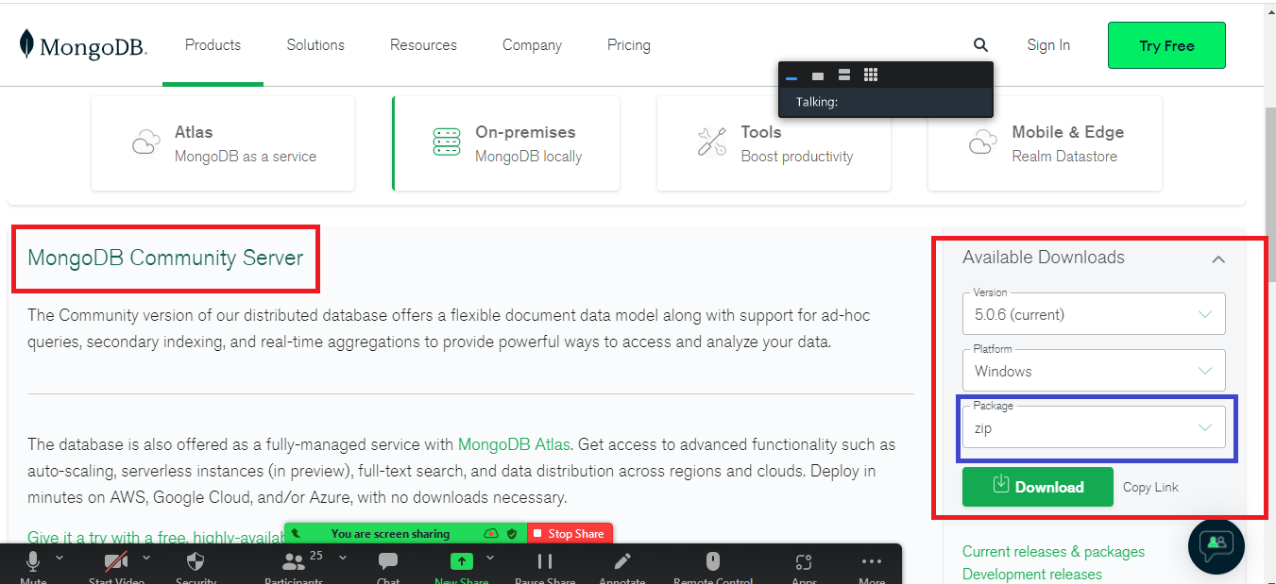

Once the zip file is downloaded, extract the zip and you will get an installation folder which is ready to use.

Once you get the mongodb installed, you need to start the mongodb database and you can use mongo-shell to interact with mongodb database, you will get to commands from /bin folder of mongodb installation folder to start the database & interact with the database, the two commands are:-

1. mongod
2. mongo

Both the above commands are present in the mongodb-instllation-folder/bin,

mongod: It is used to start the mongodb database, it usually takes 27017 port number and it starts the database by looking at a folder data/db in either C: drive or D: drive depending on where you enter mongod command.

mongo: It is used to interact with mongodb database, even this command also your terminal must recognize.

Note: You need to have minimum 2 command prompts open, one for the mongod database and another is for mongo shell(terminal)

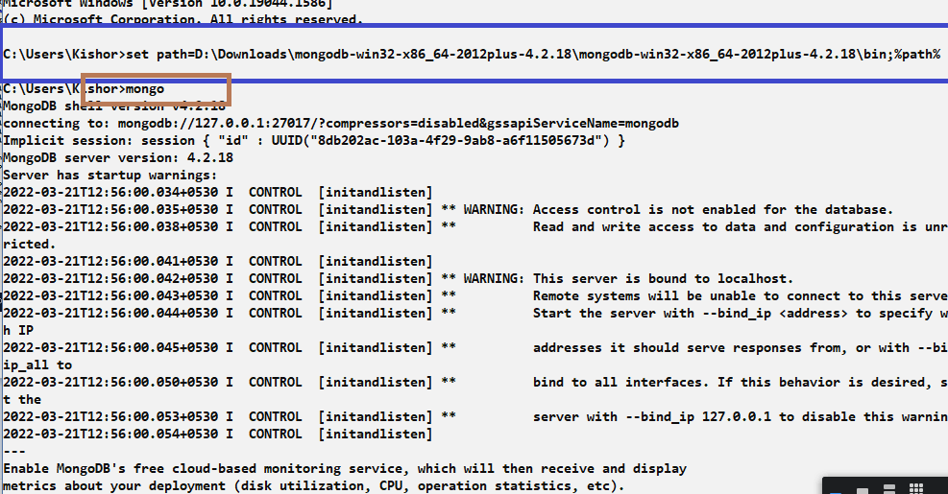

Mongo Shell: It is a terminal to interact with mongodb, which allows you to perform all the CRUD operations, similar to MySQL client

MongoDB has some inbuilt databases

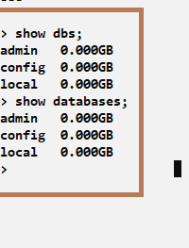

dbpath: It is an option you can use while entering the mongod command to specify the path of the database, you need to mention the location of the database the mongodb should use to store and retrieve the data

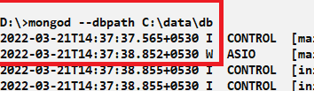

Switching to the database

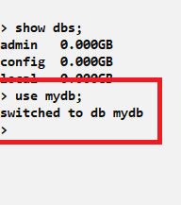

This command switches to the mydb which is a database instance, you can create collections inside the mydb.

Collection: It is like a table to store the documents

Syntax to create collection

db.createCollection(“name”);

db is going to use the current database you are using and createCollection is a function that creates the collection, it takes an argument that is the name of the collection.

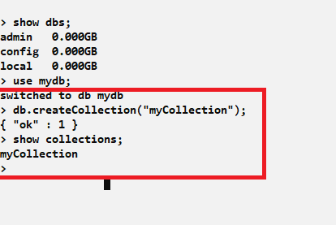

show collections: It is a command to list all the collections present in the database

You can perform various operations in the mongodb like store, retrieve, update, delete, to perform these operations we have mongodb inbuilt functions like insert(), update(), remove(), find() and so on

Storing records

You have a command called insert() and insertOne(), to store the document, insert() was a old function that only returns the status, but insertOne() is a new function that returns the status as well as the id of the record

What is id:

id is a primary key in the document, which must exist, else mongodb itself creates an id, the id will be prefixed with _, so it will be _id, _id must always be unique

insert() vs insertOne()

insert() is a function that stores the record and returns the status how many records inserted, it is deprecated

insertOne() is also a function that stores the record and returns the _id and the status, which would be very useful to the caller so that he can use that _id to perform some operations

Using insert()

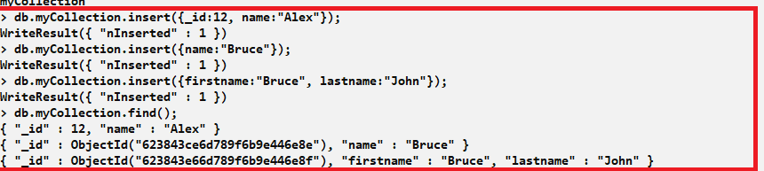

Using insertOne()

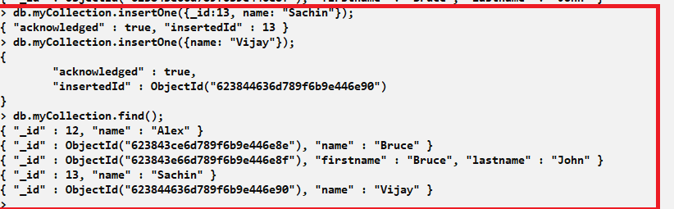

find(): It allows you to view all the documents in the collection

Bulk insert: This allows you to insert multiple documents at a time, it must be wrapped in the [], which means its an array of documents, i.e., array of objects.

insertMany() is the function we must use for bulk operations

Syntax:

db.collection_name.insertMany([{..}, {..}, {..}, …]

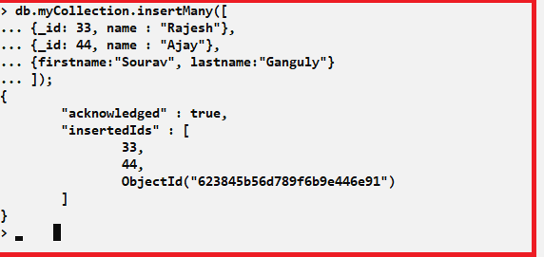

Activities:

1. Try above examples
2. Create 2 collections with the same name & different case ex: employee & EMPLOYEE and insert documents in both the collections and observe the result
3. Create a collection user with _id, name, password
4. Store some documents in the user collection
5. Find the user based on the _id i.e., view the document on a particular _id
6. Delete the user based on the _id
7. Delete all the users on one go.
8. Store some more documents in the user collection
9. Update the password of a particular user using _id